**SMILE FARM**

**Project Synopsis**

**Version 1.0**

**Industrial Training & Presentation (ECS791)**

**BACHELOR OF TECHNOLOGY (CSE)**

|  |  |
| --- | --- |
| PROJECT GUIDES:  Internal Guides:  **Mr.Mahendra Singh Sagar**  **Ms.Deepti Aggarwal**  External Guide:  **Mr. Amit Kumar Roy** | SUBMITTED BY:  **Paras Rastogi (TCA1409048)**  **Swapnil Jain(TCA1409072)** |

November,2017



**COLLEGE OF COMPUTING SCIENCES AND INFORMATION TECHNOLOGY**

**TEERTHANKER MAHAVEER UNIVERSITY, MORADABAD**

Table of Contents

1 Project Title 3

2 Domain 3

3 Problem Statement 3

4 Project Description 4

4.1 Scope of the Work 4

4.2 Project Modules 5

5 Implementation Methodology 5

6 Technologies to be used 7

6.1 Software Platform 7

6.2 Hardware Platform 7

6.3 Tools 7

7 Advantages of this Project 8

8 Future Scope and further enhancement of the Project 8

9 Team Details 8

10 Conclusion 9

11 References 9

# Project Title

“Smile Farm- an e-Revolution for Farmers”

The main objective of the project is to take the latest information and knowledge inputs to the farmers so that they can improve their productivity and economic wellbeing by registering and addressing their issues on the designed portal for effective communication and solutions.

# Domain

The Major Domain of “Smile Farm” is Cloud Computing.

# Problem Statement

The Indian farmers are dependent on timely supply of the fertilizers for maintaining their soil productivity. Majority of the Indian farmers are very poor and illiterate which results in improper application of fertilizers. They lack in awareness and education and often depend on unscrupulous middlemen for advice.

The objective is to take the latest information and knowledge inputs to farmers so that they can improve their productivity and improve their economic well-being.

# Project Description

The purpose of this document is to define scope and requirements of an agricultural initiative “Smile-Farm”. It is a vision of extending e-revolution to farmers and cooperatives through a three-pronged strategy:

a) Development of knowledge inputs and e-services of relevance to rural India,

b) Evolve effective dissemination strategies to encourage active use of the facilities by farmers & cooperatives,

c) The broad aim is to empower farmers and cooperatives through latest in information and communication technology.

User’s Request Advice + Response from SME

To User

Fig.1: 0 – Level DFD

## Scope of the Work

“Smile-Farm” will provide a secure user-id/password based login mechanism to access its services. Once logged in to the community, the user (Administrator/Content Manager/Subject Matter Expert, SME/Farmer) can use the services to fulfill their requirements. Login will be a prerequisite to use Smile-Farm. Internal users will be provided user id/password pair separately.

Once user logs in, s/he can view the dashboard of farmer queries with status, Latest Tips and Advisories added by SMEs are displayed.

## Project Modules

Smile Farm is an independent cloud community and it will have a navigation menu on the top consisting of tabs (modules) as per the access privileges specified to each user by the administrator.

* **Chatter:** this is the default landing page of each user when logged into the Smile Farm community. This module enables the user for interacting with each other effectively.
* **Dashboards:** this module is made available to both the administrator as well as the content manager. Dashboard module consists of the “Smile Farm Tracking System” to keep track of all the records present in the Smile Farm.
* **Master Modules:** this module is made available to both the administrator as well as the content manager. Master modules include specific modules such as State Master, Location Master, Category Master and SME master for data entry.
* **Category Modules:** this module is made available to both the administrator as well as the content manager. Category Modules include specific module such as SME category for the data entry.
* **Reports:**  this module is visible to both the content manager as well as the administrator for creating and analyzing the prepared reports.
* **Query Module:** this module is only visible to the farmer for addressing their issues and posting their queries. All their queries are resolved by the SME via Resolved Queries/Pending Queries module.
* **Farmer Details Module:** this module is solely made available to the farmers and the SME for registering and responding to farmer’s queries respectively.

# Implementation Methodology

All the modules of the “Smile-Farm” have been designed together to serve the purpose of interactiveness and ease of access to its different users by the help of Salesforce CRM.

The high level functional requirements for the Smile-Farm are outlined in the Use Case diagram described in this section.

Smile-Farm will provide a secure user-id/password based secured login mechanism to access its services. Once user logs in, s/he can view the dashboard of farmer queries with status, Latest Tips and Advisories added by SMEs are displayed. The implementation methodology can be well understood by the following Use-Case Diagram of ‘Smile-Farm’:

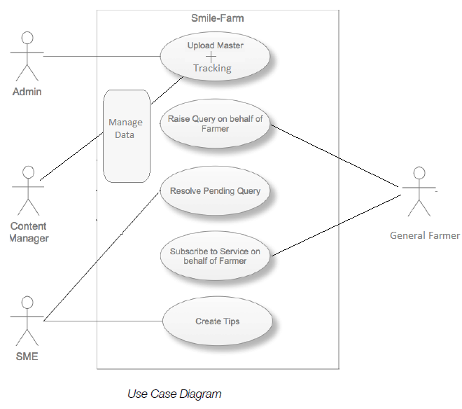

Fig.2: User Case Diagram

**Test Cases:** (Refer to SRS Appendix-E)

Test Case 1:

Only the authorized users (farmer/admin/SME/content manager) can sign into the Smile-Farm.

Test Case 2:

Testing the extent of data visible to each user (farmer/admin/SME/content manager).

Test Case 3:

Checking the “Chatter tab” to ensure a bi-directional communication between users.

Test Case 4:

Checking the Sign-up procedure to ensure data entry into the database.

Test Case 5:

Testing the delivery of E-Mail when a new farmer account is created.

# Technologies to be used

## Software Platform

1. **Front-end: Salesforce.com**
2. **Back-end: Salesforce.com Cloud Database**

## Hardware Platform

**MINIMUM HARDWARE CONFIGURATIONS:**

PROCESSOR: 800 MHz Intel Pentium III or equivalent.

RAM: 2GB

Hard Disk: 800 MB of Free Disk Space.

OS: Microsoft Windows XP/7/8/10.

Browser: Chrome (Recommended), Microsoft Edge, Mozilla Firefox etc.

**RECOMMENDED HARDWARE CONFIGURATIONS:**

PROCESSOR: 2.6 GHz Intel Pentium IV or equivalent.

RAM: 4 GB

Hard Disk: 2 GB of Free Disk Space.

OS: Microsoft Windows XP SP3/7/8/8.1/10, Ubuntu 11.04, Macintosh OS X 10.6 Intel.

Browser: Chrome (Recommended), Microsoft Edge, Mozilla Firefox etc.

## Tools

The tool that is used in SMILE FARM is as follows:

1. **Tool Name:** ApexDataLoader

**Vendor Name:** Salesforce

**Version Number: 19.00.2**

The Salesforce Data Loader / Apex Data Loader is a client application for the bulk import or export of data. The Apex Data Loader is a java-based application that can bulk process the insert, update and delete on all object data into and build queries to extract data out of salesforce.com using the Apex Web Services (SOAP) API.

# Advantages of this Project

The main advantages of ‘Smile-Farm’ are as follows:

* Raising ‘Awareness’.
* Availability and source of latest information in agriculture.
* Source of “Valuable Tips” to improve productivity and well-being.
* An interactive community for farmers to address their issues and problems.
* Farmers can register themselves conveniently to get regular updates.
* Provides SMS and E-Mail support to the users.
* Providing portability of the whole community to be accessed from anywhere in the world.

# Future Scope and further enhancement of the Project

The operability of ‘Smile-Farm’ can further be expanded to a wide scale by using the paid cloud databases and services to increase its current functional capacity.

# Team Details

| **Group#** | **Course Name** | **Student ID** | **Student Name** | **Role** | **Signature** |
| --- | --- | --- | --- | --- | --- |
| Smile-Farm Developers | B.Tech(CSE) | TCA1409072 | Swapnil Jain | Developer, Testing. |  |
| TCA1409048 | Paras Rastogi | Developer,  Designer. |  |

# Conclusion

Every system rides drawback with it. It is seen that technology gives much better advantages in 90% cases, but we can reduce gap of these drawbacks by implementing better platform for farmers and teaching them for solution to these drawbacks to make a better world.

# References

Website References:-

1. <https://trailhead.salesforce.com/en>
2. <https://www.quora.com/>
3. <https://help.salesforce.com/>
4. <https://www.youtube.com/>